

**Portuguese Water Dog Club of Greater Chicagoland**

BOARD MEETING January 17, 2024

The meeting was called to order by President David Parker at 7:40 PM on January 1, 2004.

**Members in attendance were as follows:** David Parker, Gary Novak, Theresa Hosking, Michele Wolford, Leon Benson, and Carol Holzer

**Members unable to attend were**: Susan Becker, Wendy Anderson

**Minutes –** Leonmoved to accept the Nov 12, 2023 minutes. Dave seconded the motion. The motion passed.

**Secretary Report- Action Plan discussion**

**Strategy - Inform and educate people on the PWD**

Calendar of Events –A Board Member is needed to be the liaison to the Website committee and do the following:

* Provide Board the dates for all approved PWDCGC events to the Website Committee (Giene Keyes and/or Catherine Scholz). The committee will design and manage the calendar, add our events and post it on the website.
* Michele suggested we establish Board Meeting dates for the year now and publish them. (*No decision was made on this suggestion, table until the next meeting)*.

Wendy Anderson said she would try to do this role in an email to Michele earlier today.

Dave confirmed the following calendar dates for the Club in 2024.

|  |  |
| --- | --- |
| **SOCIAL EVENTS** | **DATE** |
| Agility Fun Day (*Cindy Petrey and Theresa Hosking*) | January 28, 2024 |
| Winter Paint your dog event (*Dave to organize*) | TBD - April 2024 |
| Summer Picnic | May 18, 2024 |
| PWDCGC Annual Meeting | TBD – Fall 2024 |
| Chicago Lake Shore Dog Walk ending at a dog friendly pub – (*Carol Holzer to organize*) | TBD – Summer 2024 |

Carol Holzer will ask Karen George if she can do a Canine Massage therapy training at the May picnic.

Membership Connection Committee

Michele reported that Marsha Rosensen is mapping out Breeder Referral addresses to form pods of members who live close together and begin to connect members for small events. The committee will also partner with other committees who are creating events such as Agility Fun Days and Fit Dog to encourage participation. Theresa and Michele agreed they would bring this group together in the next month to coordinate efforts.

**Strategy - Inform and educate people on the PWD**

Gary and Michele have been working with Giene Keyes and Catherine Scholz (web designer) to start making improvements to our outdated website. We need a Board member who can share content the Board wants posted with the Website committee and to collect content the committee wants to post for Board approval. Content such as photographs, key breed information, letters from the President, resources on training and grooming, Breeder Referral lists etc. are needed, along with online membership renewal capability. Nutmeg, Pacific Northwest, and Mayflower sites are good examples.  Dave suggested that Wendy be the Board Liaison for this work as well as the Calendar. Michele will reach out to Wendy.

Dave asked if we should develop and publish social media and Shorelines “brags” guidelines for members. Board agreed that nothing has been published or posted yet that would indicate a need for guidelines, but we will continue to monitor this.

**Strategy- Encourage and promote quality in breeding of the PWD and bring natural qualities to perfection**.

* Groomers and Training facilities list- Gary will send an email to the Breeder List and ask them for their recommendations on Groomers and Training facilities we can list and post on our website.

**Strategy - Encourage sportsmanlike competition in conformation and performance and conduct sanctioned events.**

Conformation Performance

* Dave shared that he did not proof the Feb ’24 Renaissance Cluster Premium closely enough after his initial submission. MB-F took a section out and accidentally duplicated awards for both days of the show. Since it was too late to correct, Dave will bring additional gift cards (at his expense) to the show in case additional prizes are needed.
* Application was approved on 1/17/24 to host the West Bend Regional Specialty in June. Dave wants to add the CGC testing by Giene Keyes and a Fit Dog event to this specialty.
* Dave would like to create a fund raiser to purchase better awards for the West Bend Show to draw more participants. It was suggested we offer more CGC and TKN testing events at a charge.

Agility Fun Event

* Theresa Hosking and Cindy Petrey reported that the location for the 1/28/24 Agility event is free of charge and that they reached the capacity limit of 12 dogs quickly. Of the 12, only 4 dogs have done agility previously. If the event is a success, Theresa wants repeat it in other locations such as Madison, Chicago, Milwaukee, etc. to reach more members. Gary said we need a $50 Insurance rider per event. The Board agreed to charge a $30 fee per dog for this 3-hour Agility Fun Day to cover costs (future venues and insurance) and potentially return a profit.

Fit Dog

* Cindra Delgado joined the call to share her plans to build Fit Dog hikes around other PWDCGC events. West Bend will include a Fit Dog Pike Lake hike on Friday June 28. Dave will put the hike information into the Premium. A $5 State Park day pass will be required.

Strategy - Revise PWDCGC By-Laws

* Our by-laws are in total disarray. Leon Benson reported that he has totally rewritten them cross checked with Roberts Rules of Order and compared his draft to the PWDCA by-laws. Substantive changes are color coded and most have to do with electronic communication and ways to vote using technology. Leon said there is no minimum to reach quorum, so we don’t need to maintain 20% and suggested we lower quorum to 10% (which matches PWDCA). Gary said we can reach that. Leon will send out the By-Laws for us to review. Michele suggested covering this first at our next meeting.

**Treasurer’s Report**

**Treasurer’s Report January 17, 2024**

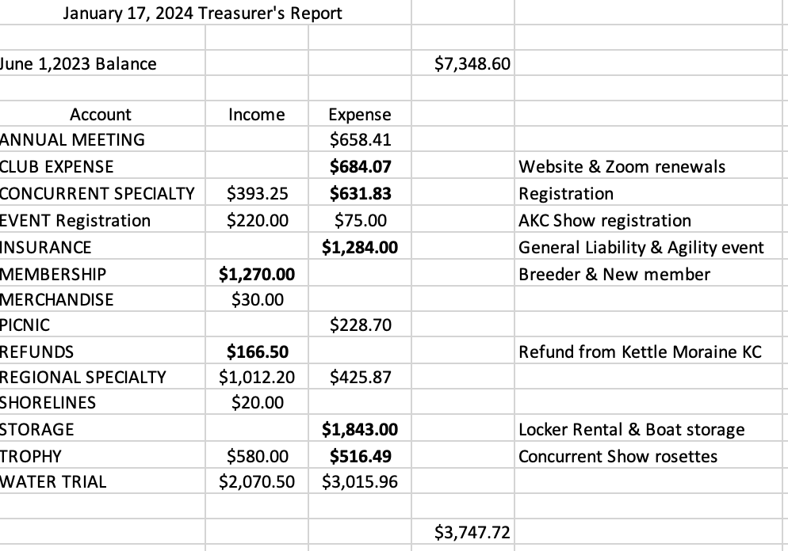

**Open forum**

National Specialty bid - Michele shared that she had submitted a letter of intent to the SEAT committee expressing our interest in hosting the 2026 National Specialty. She agreed to work with Nigel Clark and Martha Thomas to secure a site. Carol Mattingley, PWCDA SEAT Chair, asked that we try to secure a potential site in the next 30 days in order to submit our official bid.

**Adjournment** – Leon made the motion to adjourn meeting. Gary seconded. Motion passed and meeting adjourned at 9:25.