

**Portuguese Water Dog Club of Greater Chicagoland**

BOARD MEETING November 12, 2023

The meeting was called to order by President David Parker at 7:00 PM on November 12, 2023.

**Members in attendance were as follows:** David Parker, Gary Novak, Theresa Hosking, Michele Wolford, Leon Benson, and Wendy Anderson

**Members unable to attend were**: Carol Holzer and Susan Becker.

**Minutes –** Garymoved to accept the minutes from the Annual Meeting 10/14/23. Leon seconded the motion. The motion passed.

**Secretary Report- Action Plan discussion**

Strategy - Further the enjoyment of the breed

* Summer Picnic will be May 18, 2023. Make sure that the new date is posted in Shorelines. Dave will take care of arranging for the picnic and submit to Gary for the deposit.
* Dog Massage training - Karen George offered to provide this training sometime this coming year. Dave Parker will follow up with Karen to get this event scheduled.
* Fit Dog - Cindra Delgado has begun work on Fit Dog. We will leave the Board liaison position open until we determine who will work with Cindra.

Strategy - Inform and educate people on the PWD

* Membership Connection Committee - Michele will reach out to Marsha Rosenson about progress on this committee. We will have an update at the next meeting.
* Website - David reached out to Giene Keyes to work on the website. They cleaned up board member names and removed their phone numbers leaving just email addresses. They also worked on the AKC roster to update names and addresses. Michele will reach out to Giene again and Catherine Scholz who volunteered at the Annual Meeting to help us improve the overall look and content on our website to better match other Regional Club sites.

Strategy- Encourage and promote quality in breeding of the PWD and bring natural qualities to perfection.

* Groomers and Training facilities - Gary will send Michele a template to gather information. Michele will send this template to the Breeder Referral list, ask them to submit the groomers and training facilities they would recommend, and return their submissions to Gary who will compile it. This list will eventually be posted on the website.
* Breeder list – Dave suggested we relook at the Breeder List and if a breeder has not joined the Club this year we should take them off our Breeder list. Gary agreed to do this.

Strategy - Encourage sportsmanlike competition in conformation and performance and conduct sanctioned events.

* Conformation Performance – Dave has ribbons/rosettes for the first Regional Specialty in Madison in February. However, we need additional ribbons/rosettes for the second Madison show and for the Regional Specialty in West Bend. Wendy made a motion to have Dave complete the application for the West Bend show this summer. Michele seconded the motion. Dave will submit the application. We discussed potential locations for a 4th Regional Specialty next year. Leon and Michele suggested Fort Wayne which is a huge show in November and draws a lot of people. This could overlap with the Indiana Club, but they didn’t do a Specialty there this year so we should explore it. Crown Point is another option to consider but the concern there would our ability to draw enough exhibitors. Dave did a lunch there two years ago which helped attract additional people. Kalamazoo was mentioned as another potential show and location to host a Regional Specialty in November. Dave will begin looking into these locations.
* Water Committee – no update

Strategy - Improve PWDCGC FY Balance by identifying income generating events to build our financial balance in order to maintain current Club offerings and support.

* Website Online Sign up and Ecommerce - Michele will follow up with Giene and Catherine Scholz who agreed to assist us in upgrading our site capabilities.

Strategy - Revise PWDCGC By-Laws

* PWDCGC By-Laws were adopted in 1990 and Revised in 2008. Dave would like Leon to work on the Constitution and Article 1 first. Then he suggested doing the rest of the work in pieces, updating 3 Articles at a time and then submitting for Board approval until complete. Michele suggested that Leon reach out to Mary Goodman to see what progress she has already made. Barb Crowther has also offered to help with this work. We want our By-Laws to align with the PWDCA By-Laws so we don’t get too far off base.

**Treasurer’s Report**

**2023 Treasurer’s Report November 12, 2023**

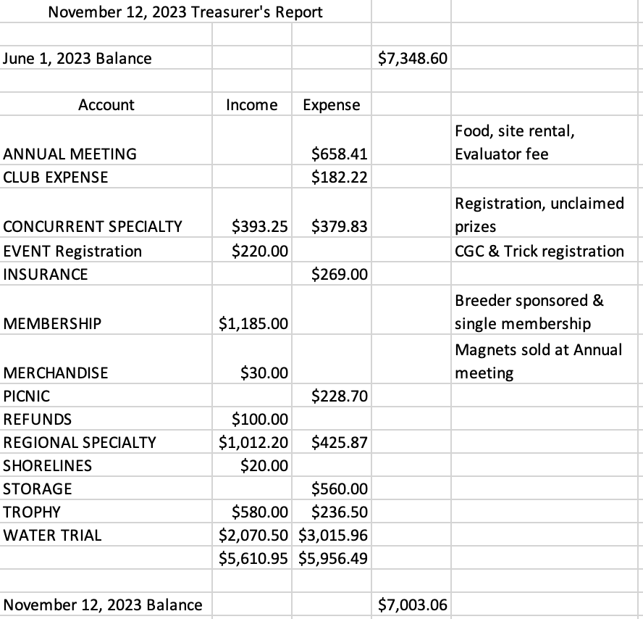

Leon made a motion to approve the August Treasurer’s Report. Theresa seconded, and the motion passed.

Gary mentioned that he will need to pay for insurance for all our upcoming events.

**Open forum**

No discussion

**Adjournment** – Gary made the motion to adjourn meeting. Theresa seconded. Motion passed and meeting adjourned at 8:07.