

**Portuguese Water Dog Club of Greater Chicagoland**

BOARD MEETING May 7, 2023

The meeting was called to order by President David Parker at 7:06 PM.

**Members in attendance were as follows:**

David Parker, Wendy Anderson, Jim Cowhey, Gary Novak, Michele Wolford, Susan Becker, Carol Holzer and Theresa Hosking joined late at 7:25 PM

**Not Present**: Cindra Delgado

**Minutes – Accept minutes of 1/29/2023**

Wendy moved to pass the minutes; it was seconded. The minutes were approved.

**Treasurer’s Report**

We are in the black by a small amount at about $3,900 (see report below). We do have $1,200 coming in from renewals to date, which will take us to about $5,100.

David asked that we create something to send to people who have joined our Facebook page but are not members of the club to see if we could get some of them to join.

Gary agreed to do this.

To date, Gary informed us that we only have 31 people/families who have renewed their membership; 2 breeder referrals, 11 Associate Memberships, 13 Single Memberships and 5 Family Memberships. Also, 22 people/families reported back to Gary that they no longer wanted to be members. Dave asked why. Gary said that several had lost their dog, others had moved away, but most of the reasons were legitimate. Gary will send out a reminder to renew next week and at the end of May.

Michele talked about the small Outreach Committee we’ve formed with three members and asked Gary to send the final list of Club Memberships so we can make calls to those who were Breeder Referrals last year but didn’t become paying members this year. We also could check in on those who have not yet renewed their membership to see if we can help close any gaps. Gary heard that some people had received a breeder referral and felt they got a nice welcome and are looking forward to getting involved.

Gary also reminded the Board that we’ve had some significant expenses in the last year to include purchasing boats, trailers and other items we weren’t counting on, but these major expenses should now be behind us. Thanks to Nigel Clark, we have a supply of ribbons for upcoming events. Dave said we still have gifts to purchase for our August event and some additional ribbons as well.

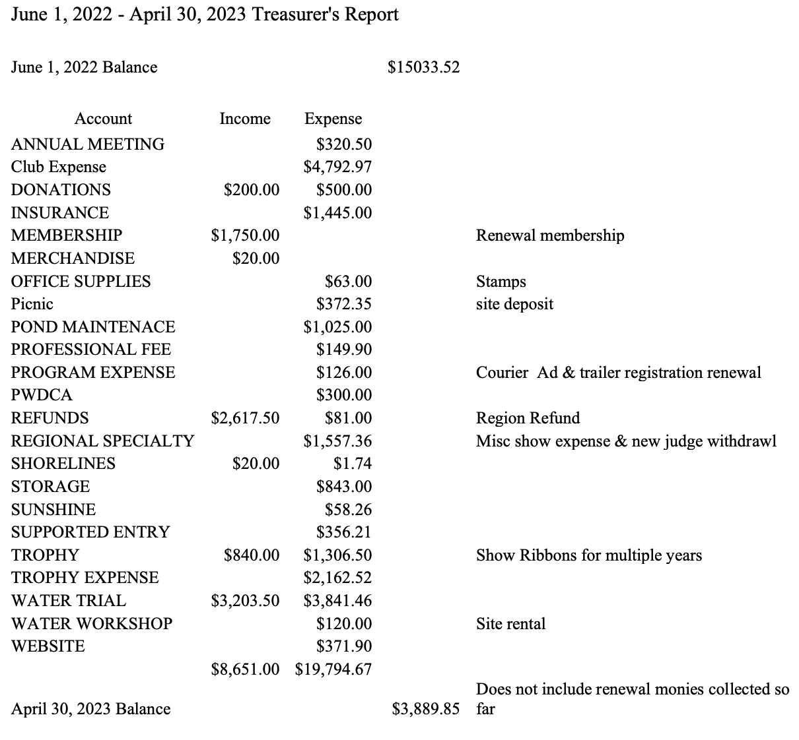

**Reports of Committees - Water 8/19-20**

Susan is working with Foster’s Training Center in Antioch, IL to use as our Water Training site this summer. Foster’s is stepping up to do the work on the pond to remove weeds and improve the sand, so there shouldn’t be too much maintenance that we will have to do on our own. Chris and Bob checked the depth of the pond and it looks OK, about 6 feet out. This may require JWD and AWD dog owners to swim vs. walk on the 1-2 minute swim exercise. Dave asked if we have to do water testing? Susan said that it isn’t needed. Bubblers may be used to control algae, and each bubbler costs around $500. Dave asked what the maintenance costs were at Tim’s pond where Water training had been held previously. Gary said we spent about $1,000 to maintain it. Dave and Susan suggested we should offer to pay for the bubblers.

The schedule for Water Training will be one day a week through the summer beginning in June.

Susan suggested that we stress the benefit of these water training sessions as a free perk to members. Michele asked if it would be appropriate to ask Club members utilizing this benefit for a small donation to help pay for the bubblers. David said we could certainly consider asking just those who are participating in the Water Trial training once we know exactly what our costs will be.

The second land training will be on May 20th

**Bylaws Committee - Jim Cowhey to be liaison**.

Mary Goodman is heading up the bylaws committee. Dave informed her that Jim Cowhey will be the liaison from the Board. The bylaws have been an issues for at least 10 years. Instead of redrafting them all at once and then sending it to Board for approval and a membership vote, Dave believes it’s best to do this work one section at a time starting with the constitution. The Board can then review each section, make edits, and move on to the next section. Over the course of several months we could complete the bylaws and then present the completed bylaws to membership for a vote. We need to align our bylaws with the National Board’s bylaws so we don’t have conflicts in our documents. It doesn’t have to match perfectly, but just be aligned. We also have outdated issues where technology like Zoom can play a role. The document also has misspelled words and other segments that need updating.

**July 1, 2023 Show**

What we Have

* Nigel Clark has the majority of the ribbons, but we may need New Puppy, new title rosettes and a few missing placement ribbons.
* Nigel has prizes ordered.
* Carrie Zimmer has agreed to lead hospitality.
* Wendy Anderson will lead the Raffle with the help of Theresa Hosking and Carol Holzer. Cindra Delgado may also assist.

What we Need

* Basket or Bag Raffle donations – Dave suggested that when we solicit for basket/bag donations we ask for the full item, not just items to fill a basket. This will simplify the work for those who are running the raffle. Baskets/Bags can be dog related or something that is completely unrelated like a Wine Basket or Gardening themed basket.
* Wendy said we need to have some sort of gift for all the attendees. Theresa will organize and contact Petalicious who will provide the gifts.
* Dave needs people to help with Awards that are not in the ring.

**Cudahy August 12, 2023**

Application sent to AKC but we have not received approval yet. AKC wants these 5 months in advance and we didn’t get it until a few weeks ago. We have been guaranteed 15 spots for Scent Work which is a rapidly growing sport for PWDs. Michele reminded the group that we need to really focus on getting families with pets involved in sports they can do with little training, like FastCAT. This could help increase attendance at our events and get breeder referral members to join the following year.

**New Business**

We need to form a Nominating Committee. While we do not have any current Officers or Board members who are hitting term limits, we need to provide the opportunity for others with interest to run for a Board position. All those who are coming to the end of their term want to stay an additional term. Dave will pull together a Nominating Committee and is looking for ideas on who might lead it.

Dave asked if the Board would be in favor of moving our meeting from the last Sunday of the month to the second Sunday of the month. All agreed.

**Calendar and club events**

Barb Novak provided an update on her search for a cost effective boat outing. Barb checked with Lake Geneva. In order to do this we need to have a private boat as dogs are not allowed on boats open to the public . A private, one hour boat fee is $750 plus $395 for a group of 20, plus tax and gratuity. That would be about $60 per person. An alternative would be downtown Chicago where there is a last cruise of the season where dogs are invited to ride. This would be a public event and Barb said the parking and getting to the boat has logistical challenges. Dave said St. Charles has two boats on the Fox River and they are paddle boats. He asked Barb to look into this. Dave says this is a great area as it has trails to walk dogs and the downtown area has restaurants that might be dog friendly.

**Dave brought up another idea of a Sip and Paint event**. Participants send their dog’s picture in advance and a template of the dog is created. Then you go and paint your dog similar to a paint by number. There is a location that does this in the far Northwest Suburbs.

Gary suggested contacting Nigel Clark as he recalls that we may have done this before. Dave said it’s about $40 per person. This might be a fun event and one that could draw members from pet families as well.

**Picnic**

Date is scheduled for 6/24/2023 from 10-4 at Ingram Dog Park in Pleasant Prairie. We do not have exclusivity at the park this year as Ingram has received complaints from residents who want to use the public dog park. Gary expressed some concern about having other dogs there for safety reasons, but Dave said any dog who has a permit to use the park must be fully vaccinated and not aggressive. We probably need to ride it out this year and if it doesn’t work well, we can look for a new location next year.

Dave suggested we offer sausages, brats, and hotdogs and then ask people to bring a potluck dish. We will assign what to bring based on the first letter of each person’s last name. (Side, dessert, etc.) Again we should work to get new members and pet families involved by inviting and welcoming them to this picnic.

**Open forum**

On odd months we need to automatically forward the minutes to Barb Crowther to publish in Shorelines and to Giene Keyes for our website.

Michele asked that we do a Special Board meeting later this week by Zoom to approve minutes only. Tonight we just approved our January Board Meeting minutes which makes it quite late for Barb and Giene to post anything current. Michele will get meeting notes out to the board in the next 24 hours. Dave will set up a 3 minute meeting this week to approve them so Michele can forward to Barb and Giene in a timely way.

Wendy asked about bidding for a PWDCA National Specialty. Dave is interested in doing a bid at Lake Geneva for 2028.

Adjournment – meeting is adjourned at 8:35. Susan approved; Theresa seconded.