

**Portuguese Water Dog Club of Greater Chicagoland**

BOARD MEETING July 9, 2023

The meeting was called to order by President David Parker at 7:04 PM July 9, 2023.

**Members in attendance were as follows:**

David Parker, Wendy Anderson, Gary Novak, Susan Becker, and Theresa Hosking Cindra Delgado

**Not Present**: Jim Cowhey, Michele Wolford, and Carol Holzer

**Minutes – No minutes to accept. Accepted at the Special Meeting.**

**Treasurer’s Report**

Below are the Fiscal Year End Report for 2022/2023 with income and expenses, and the June 2023 report for the past month.

Gary is going to correct the discrepancy for $.20 and has a good idea where the error is and will fix this. The Year End report does not include all the details of what we purchased, such as stamps and other items. A decision was made not to distribute the full financial report through Shorelines. If a member has a question, they can contact Michele or Gary. The report will be in these meeting minutes which are posted on the PWDCGC website.

Dave got an email from Midge’s husband, Chris Zurek, that he put down a deposit and paid the rent for storage and he sent a contract of what the bi-monthly cost will be. He needs to be reimbursed for $140.00 for the boat trailer. The Water Committee, Cindy sent an email as well. Their cost is $70 a month and they want approval for a boat caddy at $120 and 4 replacement oars at $80 a piece. Gary has signed up for a storage facility in Antioch through November, which is a separate thing. The trailer will hold all the Water equipment in this new storage facility. Susan Becker informed the Board that some of the oars were broken during the trial last year and this equipment is needed. There are also signs all over the area where training occurs that registration stickers are required. We made a call and found out that they are only necessary at the beach area, not where our group is training.

Next training is on July 23. Susan sends out a training reminder every Wednesday during the summer. Susan says we will have exclusivity at our Water Trial site, though things will be happening around us and on the water.

* **Susan made a Motion to pay for the Water Committee’s expenses, Gary seconded the motion. Motion passed.**

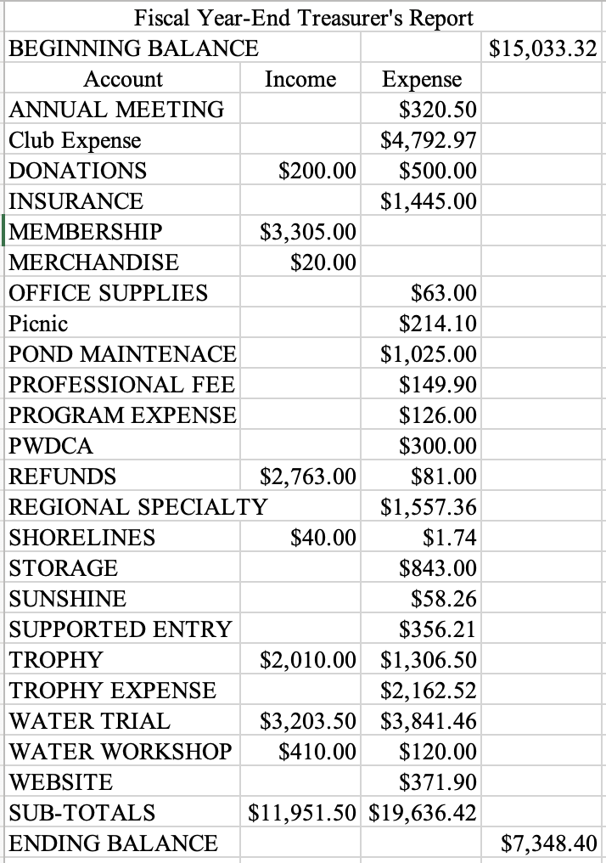

**June 1, 2023 Balance**

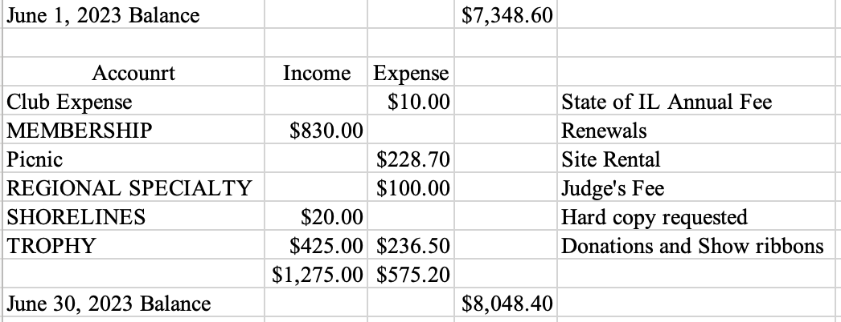

David received funds from the July Concurrent Regional Specialty in excess of $1,000. Proceeds from the show, Sweepstakes, and Basket Raffle $360. Dave also got an email from Amy Spear that there may also be an error and another check may be coming. Theresa also has a receipt to turn in for the treats/cookies. We want to use the tags to circulate and advertise our upcoming events. Theresa emailed the receipt to Gary.

**July Specialty Wrap Up**

David donated goody bags for all the judges and the junior handlers at the last show.

Wendy asked if we gave judges gas cards. David said it was not a gas card but a Visa and Starbucks inside a goody bag for the judges. David said the Conformation, Sweeps, and Juniors judge all got goody bags, so this was covered.

**August Specialty and 2024 Specialties**

David needs a check for the judge $100 and gift cards for the Ring Stewards. Decision was made not to do a raffle in August.

We need to look at the upcoming 2024 calendar to determine how many Specialties we will do next year. We need to make a decision for Renaissance in February in Madison. We need to determine if we have 2 Specialties or 1 Specialty. David wants performance associated with Conformation and is pushing back on Renaissance to do more Specialties. West Bend offers us the opportunity to do performance. Wendy wants performance. David agrees. Obedience helps our conformation entries. David will continue to work this with Ed. There are opportunities to look at other locations, West Bend, Waukesha, etc. but we also need to remember that Ed gives our Club a sizable amount of money for doing our Specialty in Madison.

**Specialty Concern Discussion**

Wendy had concerns about the show in Madison last February. She believed that some of the East Coast Handlers got picked over owner handlers and their dogs unfairly. David said this is part of the sport and everyone has a choice as to whether to hire a professional handler or handle their own dog and many of the professionally handled dogs are also beautiful. David says we want as many dogs entered from across the country as possible. That’s how our Club makes money. We also need to welcome those who want to enter from the East Coast and recognize they chose our Specialty and traveled a long way. We made $1,800 last year, with two Specialties in Madison, so we want to draw as many people as possible. There are mixed reviews about the judges in West Bend in July, but it was made clear that because our time was delayed by 40 min, our judge was then rushed for time as she had to go to Groups. A significant discussion followed with various opinions Additional research into West Bend opportunities will follow.

**MOTION – Wendy makes a motion for one regional specialty at the Madison Specialty. Cindra seconded that. Motion Passed.**

**Election Committee** – Need to get a notice sent out and have Michele send it out. We have 3 Directors that they want to come back. President wants to come back. David, Cindra, Susan, Theresa are all coming up this year. We need a date for the October meeting. David suggests October 14th for the Annual Meeting.

**MOTION – Cindra made a motion to have the Annual Meeting on October 14. Susan seconded the motion. Unanimously carried.**

June Picnic event had only 20 participants We had a family sign up but they have not paid yet.

**MEMBERSHIP** – Gary has 172 memberships out waiting for people to renew and pay. We have 16 breeder sponsored members, 22 Associate members, 32 Single Member , 20 Family members, for a total of 110 members, down by a half. We need to figure out who they are and reach out. Gary says we need to take these people off our list if they don’t renew.

Carol needs to get her renewal in. Michele can help try to reach out to these folks who didn’t respond to see if we can save some.

**GARY ASKED ABOUT BYLAWS** – Mary has been working on it. Jim Cowhey should be working on it with her.

Adjournment – Motion made by Gary to adjourn meeting. Wendy seconded.