

**Portuguese Water Dog Club of Greater Chicagoland**

BOARD MEETING September 10, 2023

The meeting was called to order by President David Parker at 7:02 PM August 13, 2023.

**Members in attendance were as follows:** David Parker, Gary Novak, Susan Becker, and Theresa Hosking, Michele Wolford, Cindra Delgado, Carol Holzer

**Members unable to attend were**: Jim Cowhey and Wendy Anderson were absent.

**Minutes –** Theresamoved to accept the minutes from the Aug 13, 2023 Board Meeting. Gary seconded the motion. The motion passed.

**Treasurer’s Report**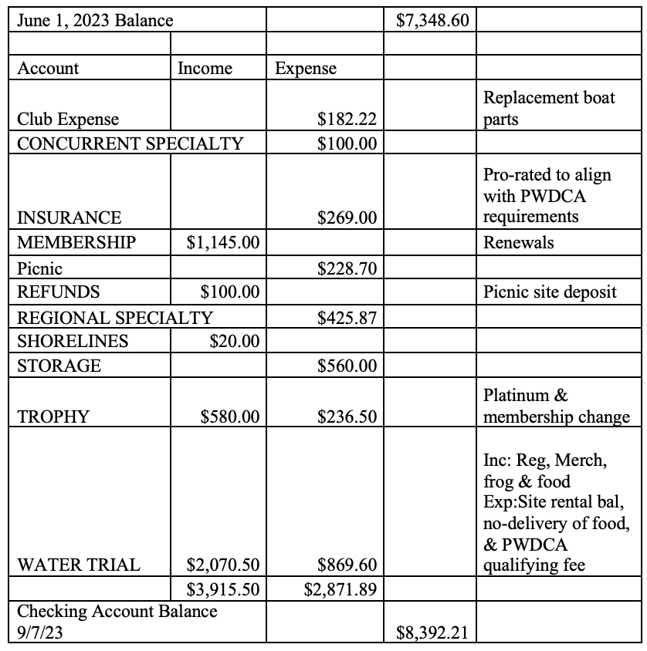

**Aug 2023 Treasurer’s Report**

Cindra made a motion to approve the August Treasurer’s Report. Michele seconded, and the motion passed.

**Membership up for vote**

**Dave will publish the new members in Shorelines**. Dave asked how many Breeder referrals have converted to being members in the second year. Michele calculated this for previous years and the numbers were fairly low, under 15%, some may be due to COVID. Cindra reinforced the need to develop more activities to draw in those breeder referrals and more pet families. Dave mentioned the idea of doing a paint your dog event, where a template is created from a picture of your dog and then those interested gather and paint their dog from this template. Dave wants more ideas we can develop for a broader group of members to include pet families.

**Reports of Committees**

Nominating Committee

We sent out a request in Shorelines last month for any members who are interested in joining the Board to let us know but there was no interest at this time . Nominating committee recommends that current officers stay in place for the coming year.

**Calendar and club events**

Annual meeting will be held on October14, at Fosters from 11:00 – 3:00. Gina, Dave’s friend, is a CGC and Trick Dog evaluator and will do evaluations at our October meeting. Dave asked if we should charge for this. Michele suggested a nominal amount should be charged to pay for Gina and make a little bit of money so we can use that to pay for other things the club needs or wants to do for members because we are still in need of income for the Club based on reduced membership. Cindra did not think we should charge for this at all. She felt it’s more important we get dogs titled and that members already have to pay AKC a fee to receive the title if they are passed by the evaluator. Carol agreed that asking for a nominal fee is OK because we are giving members a service as a benefit and convenience they would likely have to pay for elsewhere anyway. Theresa said if we offer ribbons and pay Gina, we will have to charge. Cindra asked if we know how many of our dogs have CGC already. No one has that information, so **Dave and Michele will create a message for Shorelines and an email blast to share information about this CGC/TKN opportunity and provide links from AKC describing what is required to title.** We will ask for members to RSVP if they want to be tested and leave opportunity for walk-ins if space permits. Dave asked if we would agree to a $20 fee to be tested for one title. If a member wants to do both Canine Good Citizen (CGC) and Trick Novice (TKN) testing, the fee would be $25.

**Open forum**

Michele asked that we follow up on a few loose ends from the last meeting where several people offered to help move some ideas forward.

1. **Meet the Breeds** was a success – Michele asked if we would like to officially ask Mary Goodman to Chair this committee. Dave said this is pretty much the plan already and no formal ask is likely needed. Michele asked if we had the right materials at the event? Michele created a Breeder list for our area, and a Buyer Beware check list. Carol and Susan attended and said the families really liked stickers that they had and asked for the breeder list. People wanted to know the average price for a dog. The Breeder Beware list had one line that said a reputable breeder doesn’t use the word Portie, but the signage provided for the event has Portie written on the booth. We likely need to remove that line from the Buyer Beware list if we can’t change the signage.
2. **Jim asked at the last meeting about creating a list of Training facilities** (and possibly a list of groomers) and post them to our website. Michele suggested we use the breeder list and contact those members first to begin to gather this list of facilities? Dave said we have to be careful with this because we don’t want to be liable for recommending a place that doesn’t work out for a member. Michele suggested we have a disclaimer on the list for the PWDCGC to make it clear this is a member compiled list and we are not endorsing or supporting any list and are not responsible for a bad experience. Dave said having the list would help him police the Facebook site by referring people who ask this question to our website and people can add to the list going forward. **Gary agreed to be the person who will receive the information and compile it.**
3. **Cindra mentioned starting a “Fit Dog” committee** to encourage all PWD families to do more with their dogs across our geography. Cindra does not have capacity to take this on right now but wants to have a CGC qualified evaluator to be in charge of it. Cindra is looking for a trainer now and is still looking for someone. **Dave asked if Cindra would organize this program for us if and when we get an evaluator identified.** We could add evaluation for Fit Dog to one of our Regional Specialties, probably West Bend.

Dave asked when Gary will publish the membership directory. Gary said he does this in October or November.

Gary asked what is happening with the By Laws. Dave said since Jim is not here tonight, we can’t get the update. **As follow up, we will ask Jim to give us an update at the next Board Meeting.**

**Adjournment –** Cindra made the Motion made by to adjourn meeting. Susan seconded. Motion passed and meeting adjourned at 8:14.